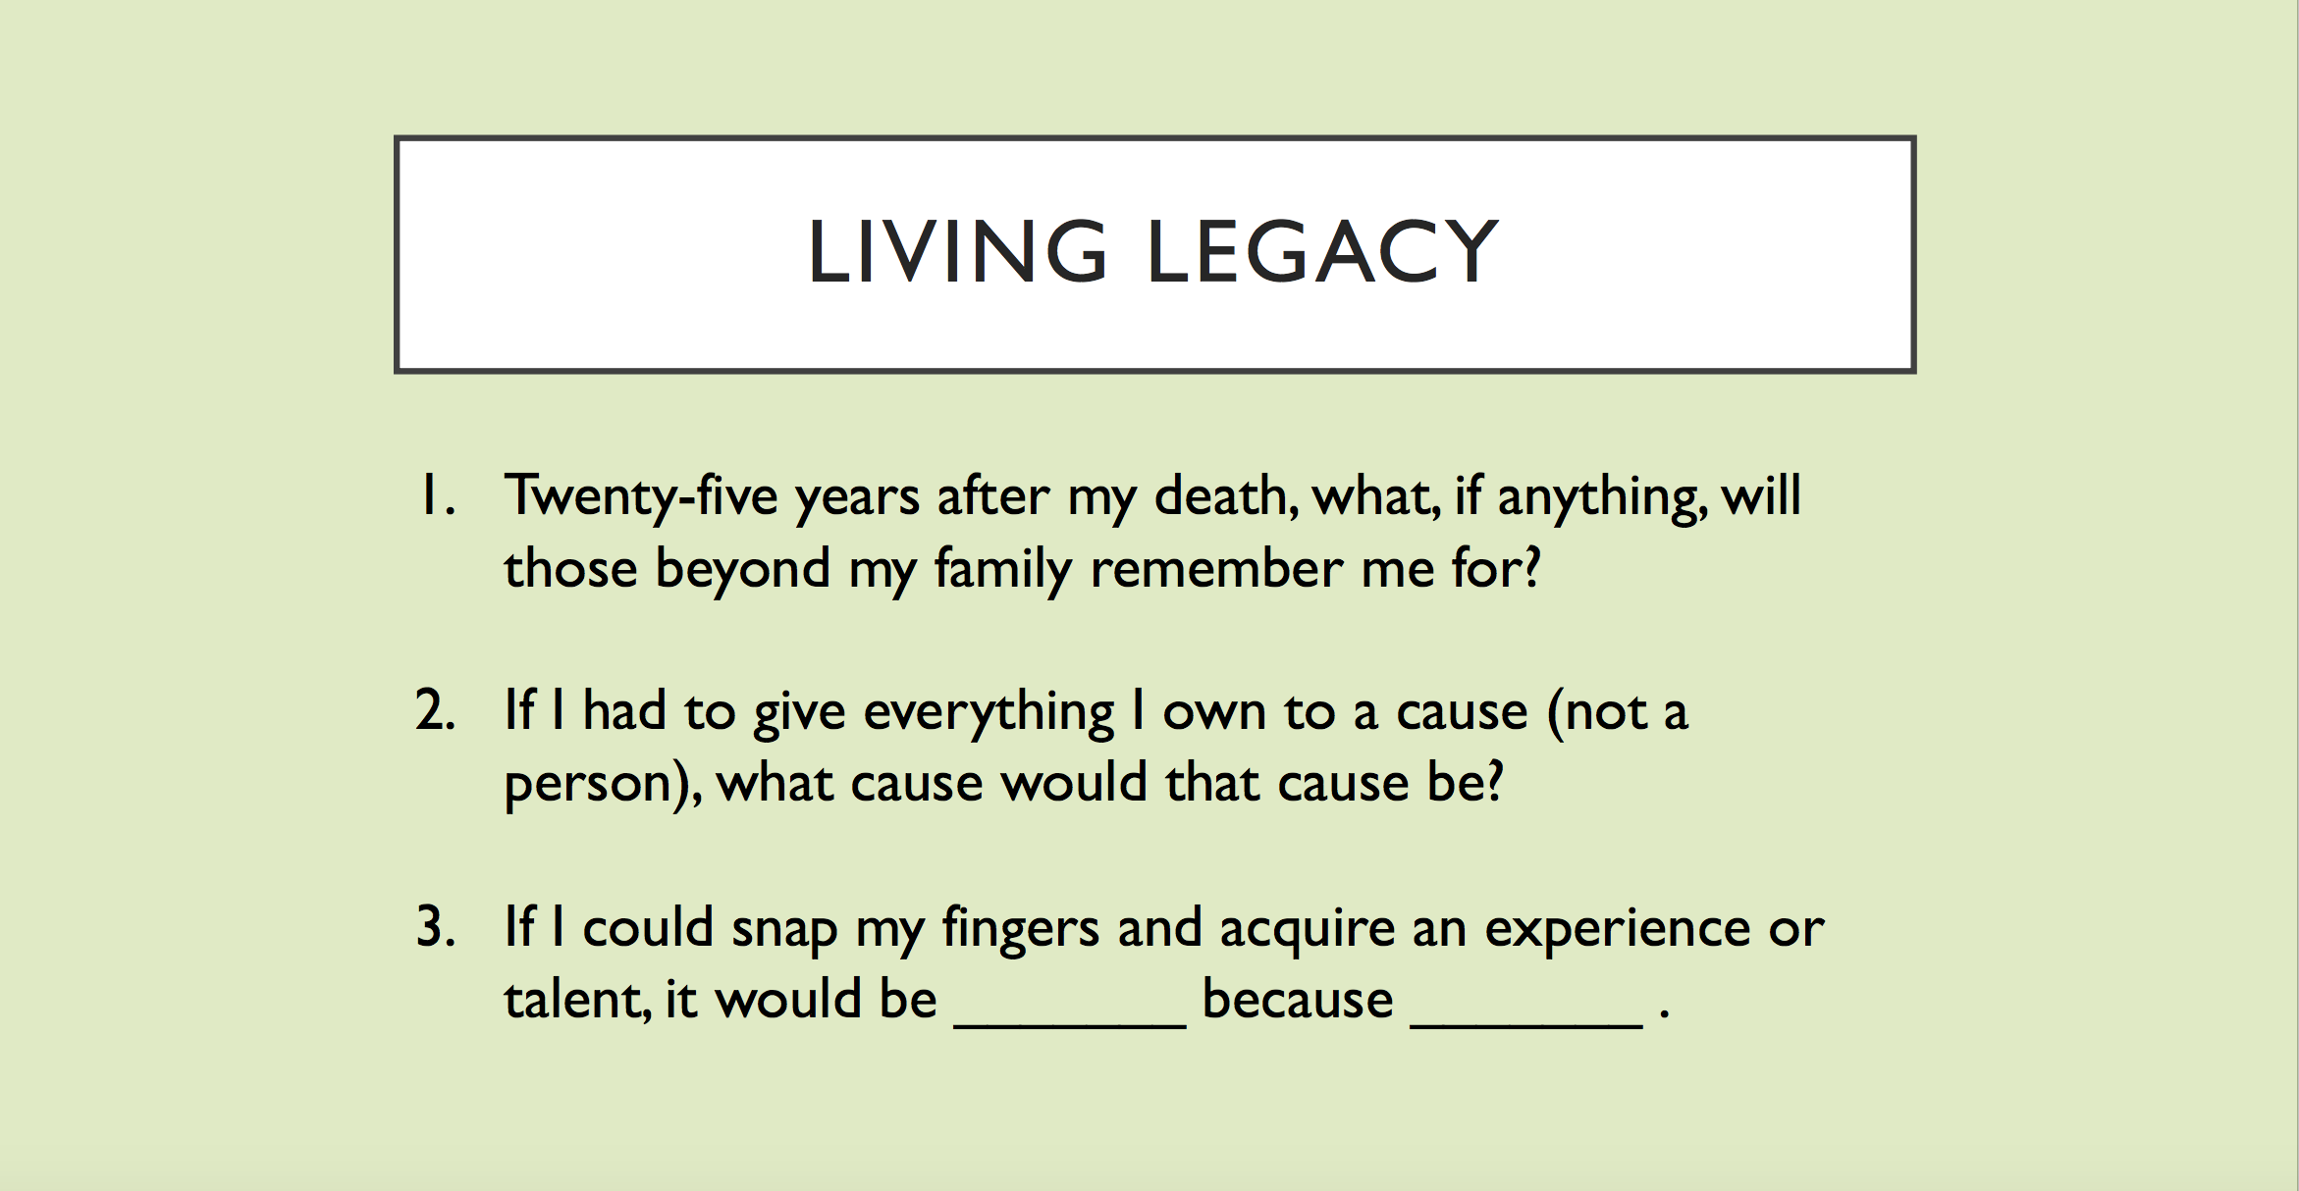

1. (answer here)

_______________________________________________________________________________

_______________________________________________________________________________

_______________________________________________________________________________

2. (answer here)

_______________________________________________________________________________

_______________________________________________________________________________

_______________________________________________________________________________

3. (answer here)

_______________________________________________________________________________

_______________________________________________________________________________

_______________________________________________________________________________

3.